

**SE-200: Software Engineering**

**Project Assignment # 1**

**Submitted To:**

**Dr Madiha Khalid**

**Submitted By:**CLASS: BESE-13-A

|  |
| --- |
| Aimen Munawar  Muqaddas Anees  Hasnain Ali |

1. **Title and Group Members**

**Title: UniRide:** University Ride-Share Network for H-12 and H-11 Students

**Group Members:**

|  |  |
| --- | --- |
| **Name** | **CMS ID** |
| Aimen Munawar | 415867 |
| Muqaddas Anees | 407476 |
| Hasnain Ali | 408547 |

1. **System Overview/Problem Description**

**Problem Statement:**

Persistent traffic congestion in the H-12 and H-11 neighborhoods surrounding the university makes it difficult for students to get to campus on time and contributes to environmental degradation. With this project, a thorough ride-sharing network will be created specifically for university students in these regions. The system will use technology to link students who commute along comparable routes, promoting carpooling as an effective, affordable, and environmentally friendly mode of transportation. By doing this, we hope to ease traffic congestion, cut down on individual commuting expenditures, and help create a more environmentally friendly campus environment.

1. **Importance and Benefits:**

* Lessened Traffic Congestion: By encouraging carpooling, the project hopes to significantly reduce the number of vehicles on the road. Congestion will be reduced as a result.
* Cost-saving: By sharing rides and pooling their resources, students can lower the price of transportation, making it more accessible and cheaper for everyone.
* Environmental Impact: Carpooling helps create a greener campus by reducing the carbon footprint associated with individual commuting.
* Better Punctuality: By employing this method, students will find it easier to arrive and depart from the university on time, which will improve their entire academic experience.
* Community Building: The platform will foster a feeling of community among students by enabling them to connect and network during shared rides.

1. **Project Scope and Objectives**

**Scope of Initial Release:**

* **User Registration and Profiles:** Users can create accounts, providing necessary information like name, contact details, and university affiliation.
* **Ride Posting and Searching:** Students can post rides available or search for rides to specific destinations.
* **Algorithm for User Matching:** The system will utilize an algorithm to pair users according to their routes and preferences.
* **Scheduling and Notifications:** The system will facilitate scheduling of rides and notify users about ride confirmations, updates, and cancellations.
* **Rating and Reviews:** Users can rate and leave reviews for drivers, ensuring a safe and reliable ride-sharing experience.

**Scope of Subsequent Releases:**

* **Integration with Campus Events:** Connect ride-sharing options with major university events and activities.
* **Payment Integration:** Implement a payment system for drivers to receive contributions towards fuel expenses.
* **Expanded Geographical Coverage:** Extend the service to cover nearby campuses and areas.
* **Dynamic Route Optimization:** Implement an algorithm for efficient route planning and matching of riders.
* **Accessibility Features:** Introduce features for differently-abled students to ensure inclusivity.

**Limitations and Exclusions:**

* **Geographical Constraints:** The system will initially focus on the H-12 and H-11 areas.
* **Security and Privacy:** While encryption will be implemented, absolute security cannot be guaranteed.
* **Emergency Situations:** The system will not be equipped to handle emergency situations.

1. **Feasibility**

**Technical:**

Expertise in algorithm design, geolocation services, and mobile app development are required for this project. The system will prioritize data security and privacy, which necessitates intensive testing and debugging. The adaptability of the system will be maintained to accept alterations in user data, such as leaves, while continuing to grant access to authorized users.

**Operational:**

For the system to work as best it can, proper setup and routine maintenance are essential. There will be regular maintenance checks to address any potential problems. The system will also be made to be simple to update and upgrade, increasing its operational flexibility.

**Economic:**

The cost of putting the system into place will include costs for marketing, server hosting, and software development. Although advantageous, installing location-based hardware could result in extra costs. While assuring the system's performance and sustainability, we will investigate cost-effective approaches.

1. **Stakeholders**

* **Students:**

**Roles and responsibilities:**

* Register and maintain their profiles on the platform.
* Post and manage ride offer.
* Search and request rides from other students.
* Provide feedback on ride experiences.
* **Administrators:**

**Roles and responsibilities:**

* Access the system with administrative privileges.
* Verify and manage student profiles.
* Monitor system activity and ensure data accuracy and security.
* **University Management:**

**Roles and responsibilities:**

* Providing support and endorsement for the project
* Promoting the platform among students
* **Local Transportation Authorities:**

**Roles and responsibilities:**

* Coordinating with the project for traffic management
* Providing necessary data for optimization
* **Project Team:**

**Roles and responsibilities:**

* Collaboratively develop, test, and maintain the system.
* Ensure continuous improvement and feature enhancements.
* Implement effective quality assurance and testing procedures.
* Address user feedback and resolve issues promptly.
* Maintain the project's long-term sustainability and scalability.
* **Potential Sponsors/Partners:**

**Roles and responsibilities:**

* Offering financial or in-kind support
* Collaborating for mutual benefit

1. **Methodology**

For the development of the Ride-Share Network, we have opted for a combination of the Waterfall model and Incremental Models. This choice is rooted in the following key considerations:

* **Project Scope Clarity:** The Waterfall model's sequential and structured approach suits projects with well-defined, stable requirements. In this context, the objectives and scope of the Ride-Share Network are clear and not anticipated to undergo significant changes.
* **Incremental Model for Continuous Improvement:** By integrating Incremental Models within the Waterfall framework, we break the project into manageable phases. Each phase delivers a set of features that can be tested, refined, and improved based on user and stakeholder feedback.
* **Stakeholder Involvement:** With multiple stakeholders including students, faculty, and administration, our approach ensures effective integration of their input at various stages. This adaptability and responsiveness are critical for success.
* **Clear Documentation and Traceability:** The Waterfall model mandates thorough documentation, crucial for a project involving carpooling, emphasizing safety, reliability, and compliance. It provides an audit trail of decisions and progress, essential for a ride-sharing application.
* **Risk Mitigation:** The phased approach of Waterfall aids in early identification and resolution of potential issues, reducing the risk of major setbacks. Additionally, the incremental model allows timely adjustments in response to unforeseen challenges or opportunities.
* **Regulatory Compliance:** Given the transportation and safety aspects, adherence to legal and safety regulations is paramount. The structured nature of the Waterfall model ensures that each phase undergoes comprehensive compliance checks.

1. **Risk Assessment**

**Potential Risks:**

* **User Adoption and Engagement:** Low adoption rate and engagement by students due to lack of awareness or resistance to change.
* **Technology Compatibility:** Incompatibility of chosen technologies with specific platforms or devices used by students.
* **Data Privacy and Security:** Vulnerability to data breaches or unauthorized access to user information.
* **Regulatory Compliance:** Non-compliance with local transportation regulations and privacy laws.

**Mitigation Strategies:**

* **User Adoption and Engagement:**
  + **Strategy 1:** Conduct extensive user research to understand preferences and pain points.
  + **Strategy 2:** Implement a robust onboarding process with tutorials and support channels.
* **Technology Compatibility:**
  + **Strategy 1:** Regularly update and validate compatibility with popular platforms and devices.
  + **Strategy 2:** Provide alternative options or features for users with incompatible technology.
* **Data Privacy and Security:**
  + **Strategy 1:** Employ encryption and secure protocols for data transmission and storage.
  + **Strategy 2:** Regularly monitor and update security measures based on emerging threats and best practices.
* **Regulatory Compliance:**
  + **Strategy 1:** Collaborate with legal experts for continuous compliance assessment and updates.
  + **Strategy 2:** Implement features for users to customize their preferences based on local regulations.

1. **Project Timelines**

**Preliminary Timeline & Milestones:**

**Initial Release Phase:**

* **User Registration and Profiles:**
  + Step 1: Database Design and Schema
    - Start: October 16, 2023
    - End: October 30, 2023
    - Duration: 11 days
    - Approx. 2 weeks
  + Step 2: User Interface and Registration Form
    - Start: October 31, 2023
    - End: November 13, 2023
    - Duration: 10 days
    - Approx. 2 weeks
  + Step 3: User Profile Customization
    - Start: November 14, 2023
    - End: November 27, 2023
    - Duration: 10 days
    - Approx. 2 weeks
  + Step 4: Data Validation and Security Measures
    - Start: November 28, 2023
    - End: December 11, 2023
    - Duration: 10 days
    - Approx. 2 weeks
  + Step 5: Testing and Debugging
    - Start: December 12, 2023
    - End: December 25, 2023
    - Duration: 10 days
    - Approx. 2 weeks

**Milestone 1.1 :** User Registration and Profile Completion

* + - Start: October 16, 2023
    - End: December 25, 2023
    - Duration: 51 days
    - Approx.10 weeks

**Gantt Chart:**

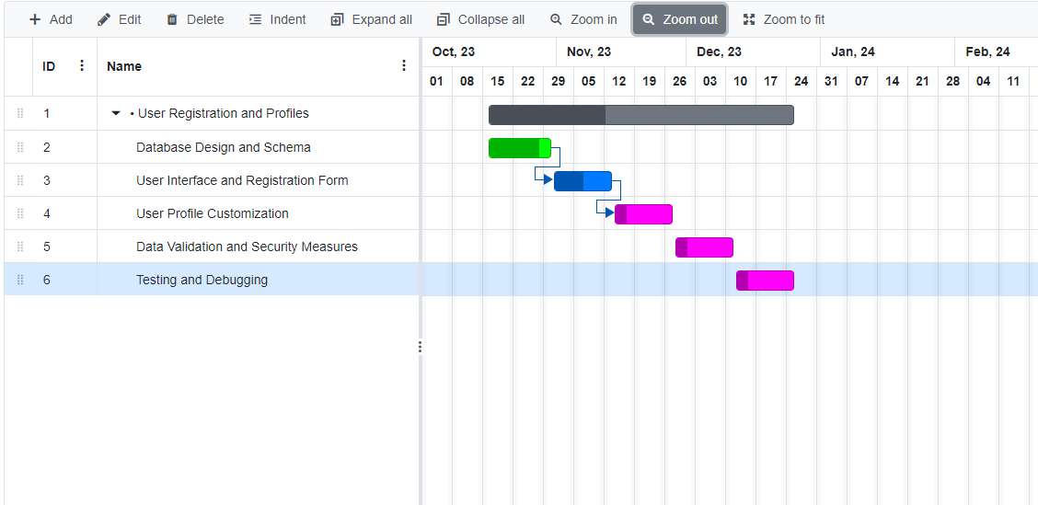

* **Ride Posting and Searching:**
  + Step 1: Ride Posting Form and Database Integration
    - Start: December 27, 2023
    - End: January 8, 2024
    - Duration: 9 days
    - Approx. 2 weeks
  + Step 2: Ride Search Functionality
    - Start: January 9, 2024
    - End: January 22, 2024
    - Duration: 10 days
    - Approx. 2 weeks
  + Step 3: Map Integration for Ride Selection
    - Start: January 23, 2024
    - End: February 5, 2024
    - Duration: 10 days
    - Approx. 2 weeks
  + Step 4: Testing and Debugging
    - Start: February 6, 2024
    - End: February 19, 2024
    - Duration: 10 days
    - Approx. 2 weeks

**Milestone 1.2 :**Ride Posting and Searching Completion

* + - Start: December 27, 2023
    - End: February 19, 2024
    - Duration: 54 day
    - Approx. 7 weeks and 5 days

**Gantt Chart:**

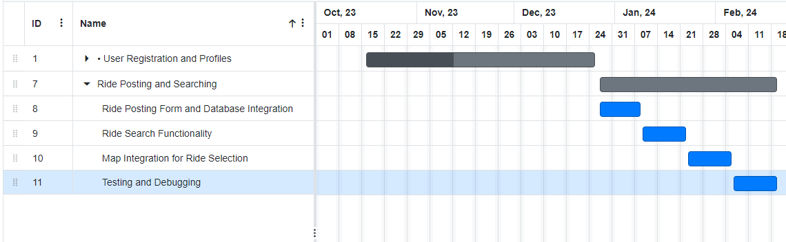

* **Algorithm for User Matching:**
  + Step 1: Define Matching Criteria and Parameters
    - Start: February 21, 2024
    - End: March 5, 2024
    - Duration: 10 days
    - Approx. 2 weeks
  + Step 2: Implement Matching Algorithm
    - Start: March 6, 2024
    - End: March 19, 2024
    - Duration: 10 days
    - Approx. 2 weeks
  + Step 3: Test Matching Algorithm
    - Start: March 20, 2024
    - End: April 2, 2024
    - Duration: 10 days
    - Approx. 2 weeks
  + Step 4: Fine-tune Algorithm for Efficiency
    - Start: April 3, 2024
    - End: April 16, 2024
    - Duration: 10 days
    - Approx. 2 weeks

**Milestone 1.3 :** User Matching Algorithm Completion

* + - Start: February 21, 2024
    - End: April 16, 2024
    - Duration:56 day
    - Approx. 8 weeks

**Gantt Chart:**

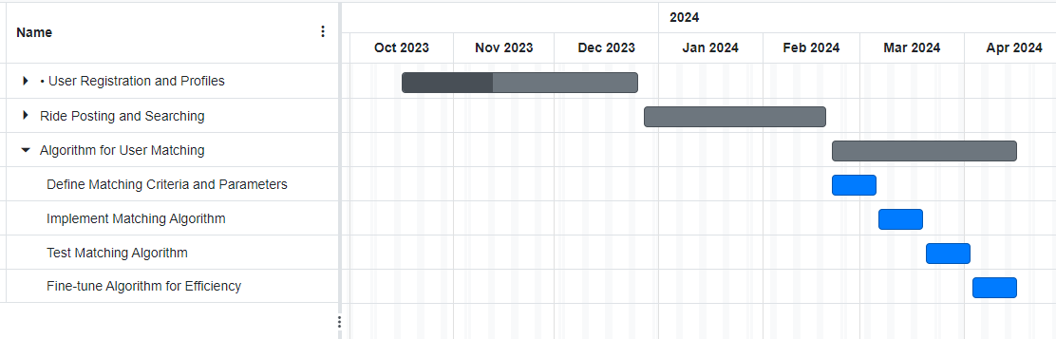

* **Scheduling and Notifications:**
  + **Step 1: Develop Scheduling Interface**
    - Start: April 18, 2024
    - End: May 1, 2024
    - Duration: 10 days
    - Approx. 2 weeks
  + **Step 2: Implement Notification System**
    - Start: May 2, 2024
    - End: May 15, 2024
    - Duration: 10 days
    - Approx. 2 weeks
  + **Step 3: Integrate Calendar Functionality**
    - Start: May 16, 2024
    - End: May 29, 2024
    - Duration: 10 days
    - Approx. 2 weeks
  + **Step 4: Testing and Debugging**
    - Start: May 30, 2024
    - End: June 12, 2024
    - Duration: 10 days
    - Approx. 2 weeks

**Milestone 1.4 :**Scheduling and Notifications Completion

* + - Start: April 18, 2024
    - End: June 12, 2024
    - Duration: 56 day
    - Approx. 8 weeks

**Gantt Chart:**

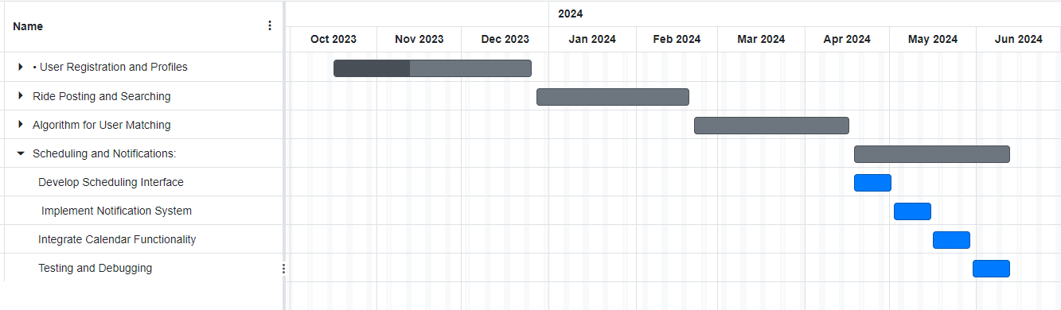

* **Rating and Reviews:**
  + Step 1: Create Rating System and Database Schema
    - Start: June 14, 2024
    - End: June 26, 2024
    - Duration: 10 days
    - Approx. 2 weeks
  + Step 2: Implement User Interface for Rating
    - Start: June 27, 2024
    - End: July 10, 2024
    - Duration: 10 days
    - Approx. 2 weeks
  + Step 3: Enable Review Submission
    - Start: July 11, 2024
    - End: July 24, 2024
    - Duration: 10 days
    - Approx. 2 weeks
  + Step 4: Testing and Debugging
    - Start: July 25, 2024
    - End: August 7, 2024
    - Duration: 10 days
    - Approx. 2 weeks

**Milestone 1.5 :**Rating and Reviews Completion

* + - Start: June 14, 2024
    - End: August 7, 2024
    - Duration:55 day
    - Approx. 7 weeks and 6 days

**Gantt Chart:**

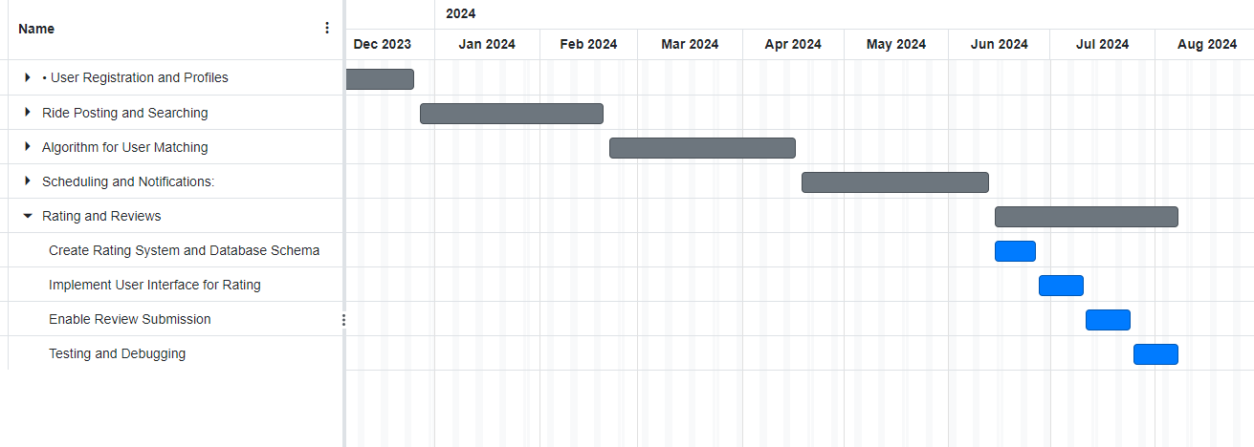

**Subsequent Release Phase:**

* **Integration with Campus Events**
  + Step 1: Establish Interface with Campus Events Calendar
    - Start: August 8, 2024
    - End: August 21, 2024
    - Duration: 10 days
    - Approx. 1 week and 3 days
  + Step 2: Enable Ride Sharing for Events
    - Start: August 22, 2024
    - End: September 4, 2024
    - Duration: 10 days
    - Approx. 1 week and 3 days
  + Step 3: Test Integration with Mock Events
    - Start: September 5, 2024
    - End: September 18, 2024
    - Duration: 10 days
    - Approx. 1 week and 3 days

**Milestone 2.1 -** Integration with Campus Events Completion

* + - Start: August 8, 2024
    - End: September 18, 2024
    - Duration: 42 day
    - Approx. 6 weeks

**Gantt Chart:**

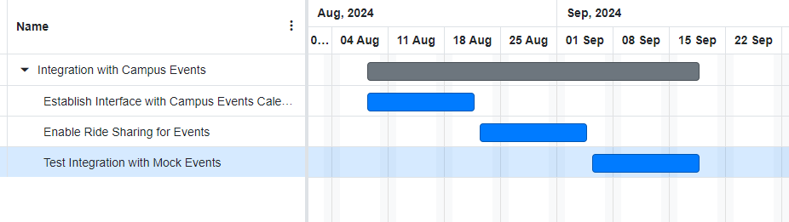

* **Payment Integration**
  + Step 1: Research and Select Payment Gateway
    - Start: September 19, 2024
    - End: October 2, 2024
    - Duration: 10 days
    - Approx. 1 week and 3 days
  + Step 2: Integrate Payment System
    - Start: October 3, 2024
    - End: October 16, 2024
    - Duration: 10 days
    - Approx. 1 week and 3 days
  + Step 3: Test Payment Transactions
    - Start: October 17, 2024
    - End: October 30, 2024
    - Duration: 10 days
    - Approx. 1 week and 3 days

**Milestone 2.2 - Payment Integration Completion**

* + - Start: September 19, 2024
    - End: October 30, 2024
    - Duration: 42 day
    - Approx. 6 weeks

**Gantt Chart:**

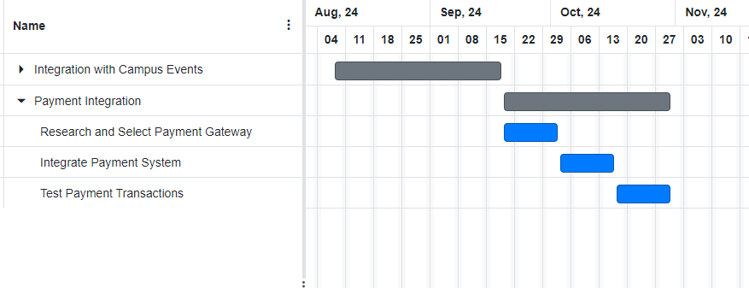

* **Expanded Geographical Coverage**
  + Step 1: Research Nearby Campuses and Areas
    - Start: October 31, 2024
    - End: November 13, 2024
    - Duration: 10 days
    - Approx. 1 week and 3 days
  + Step 2: Extend Service to Additional Areas
    - Start: November 14, 2024
    - End: November 27, 2024
    - Duration: 10 days
    - Approx. 1 week and 3 days
  + Step 3: Test and Validate Expansion
    - Start: November 28, 2024
    - End: December 11, 2024
    - Duration: 10 days
    - Approx. 1 week and 3 days

Milestone 2.3 - Expanded Geographical Coverage Completion

* + - Start: October 31, 2024
    - End: December 11, 2024
    - Duration: 41 days
    - Approx. 5 weeks and 6 days

**Gantt Chart:**

* **Dynamic Route Optimization**
  + Step 1: Research and Select Optimization Algorithm
    - Start: December 12, 2024
    - End: December 25, 2024
    - Duration: 10 days
    - Approx. 1 week and 3 days
  + Step 2: Implement Algorithm for Efficient Routing
    - Start: December 26, 2024
    - End: January 8, 2025
    - Duration: 10 days
    - Approx. 1 week and 3 days
  + Step 3: Test and Fine-tune Route Optimization
    - Start: January 9, 2025
    - End: January 22, 2025
    - Duration: 10 days
    - Approx. 1 week and 3 days

**Milestone 2.4 - Dynamic Route Optimization Completion**

* + - Start: December 12, 2024
    - End: January 22, 2025
    - Duration: 42 days
    - Approx. 6 weeks

**Gantt Chart:**

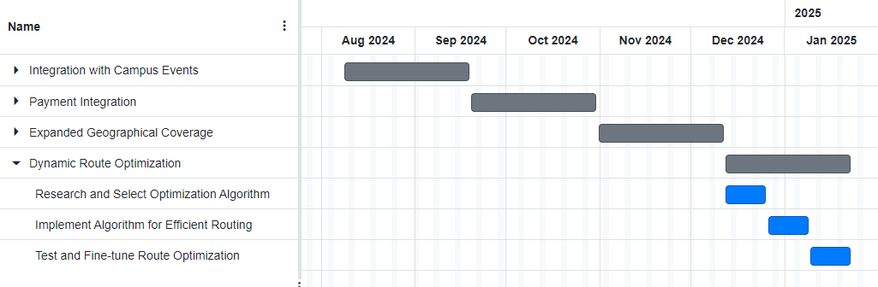

* **Accessibility Features**
  + Step 1: Identify and Implement Accessibility Tools
    - Start: January 23, 2025
    - End: February 5, 2025
    - Duration: 10 days
    - Approx. 1 week and 3 days
  + Step 2: User Testing for Accessibility
    - Start: February 6, 2025
    - End: February 19, 2025
    - Duration: 10 days
    - Approx. 1 week and 3 days
  + Step 3: Fine-tune Accessibility Features
    - Start: February 20, 2025
    - End: March 5, 2025
    - Duration: 10 days
    - Approx. 1 week and 3 days

Milestone 2.5 - Accessibility Features Completion

* + - Start: January 23, 2025
    - End: March 5, 2025
    - Duration: 41 day
    - Approx.5 weeks and 6 days

**Gantt Chart:**

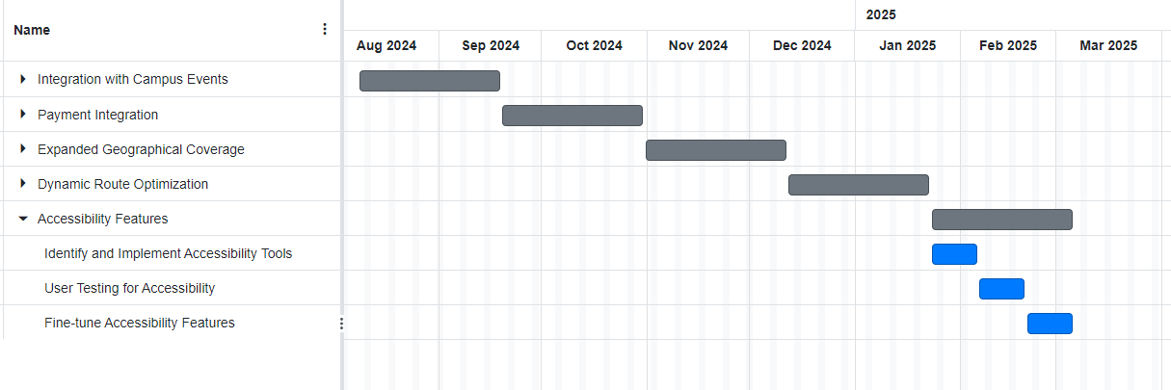

Milestone 3 - Final Release

* + - Start: October 16,2023
    - End: March 5, 2025
    - Duration: 502 days
    - Approx.5 weeks and 6 days